OBSERVATION1:

In wireframe forgot password option is there but in login page it is not there.

Wireframe: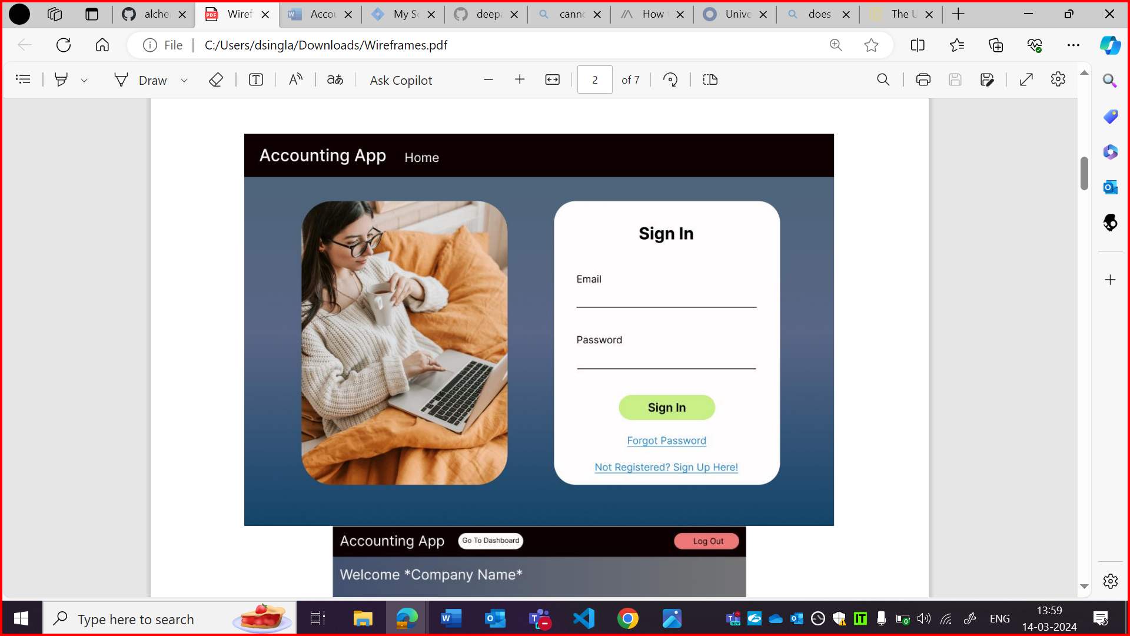

Login page:

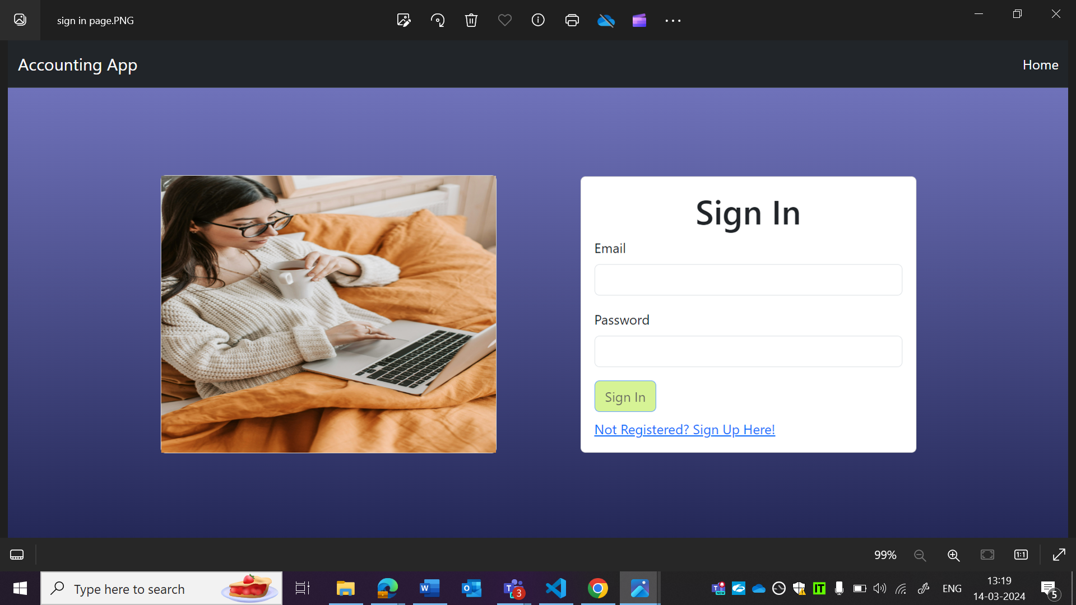

OBSERVATION2:

Highlighted text is not centre aligned as per wireframe.

Sign in button is not in same style as wireframe.

Wireframe:

Login page:



OBSERVATION3:

Home button is not aligned as per wireframe.

Wireframe:

Login page:



OBSERVATION4:

Image and box is not in same dimensions as per wireframe.

Wireframe:

Login page:

